Ар

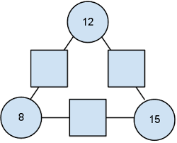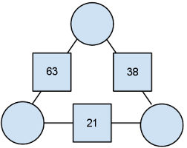

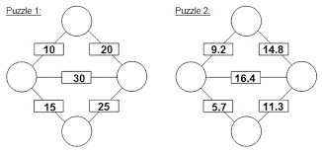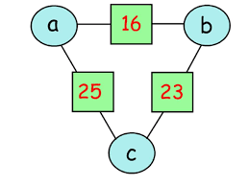 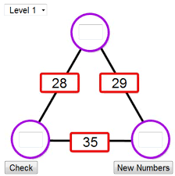

Магични квадрати

|  |  |  |
| --- | --- | --- |
|  | 14 |  |
|  |  |  |
| 20 | 30 | 16 |

|  |  |  |
| --- | --- | --- |
| 14 |  |  |
| 17 | 12 |  |
| 5 |  |  |

|  |  |  |
| --- | --- | --- |
| 31 |  |  |
|  | 29 | 25 |
|  |  | 27 |

https://nrich.maths.org/2670

http://www.ictgames.com/magicSquare /index.html